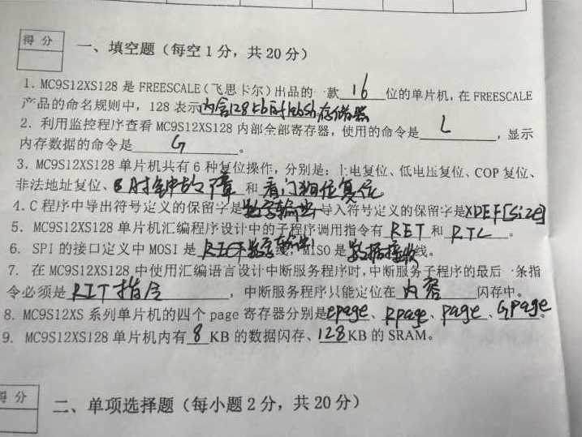
- 16，内含128KB的Flash存储器
- R，D
- 时钟复位，外部复位
- XDEF[sixe]，XREF[size]
- 主机输出、从机输入数据线，主机输入、从机输出数据线？
- PPAGE,RPAGE,GPAGE,EPAGE
- RTI指令，程序
- PPAGE,RPAGE,GPAGE,EPAGE
- 8，8
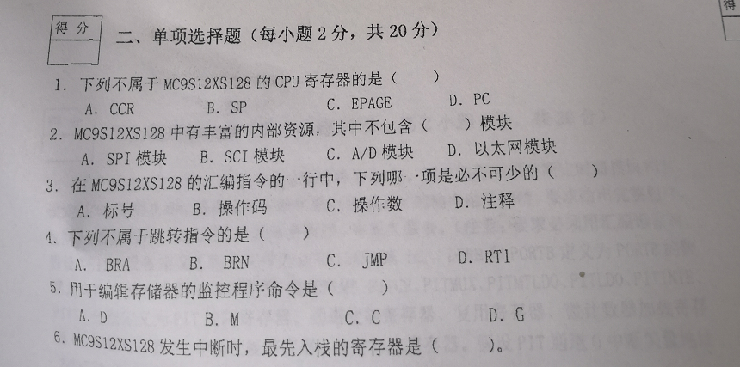
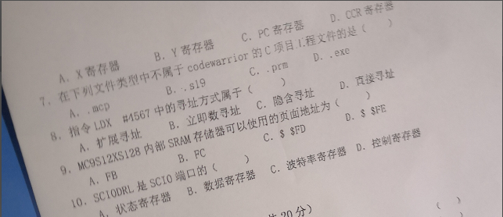
- B
6. C?
7.？
9.？
选择题：BDBCB DBBAB
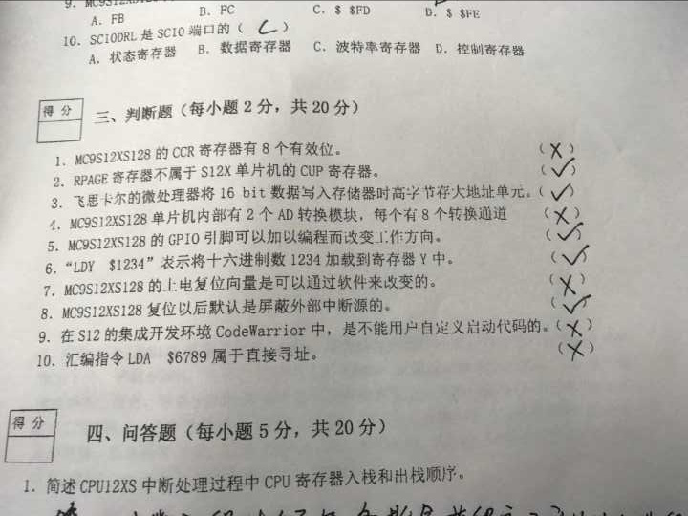
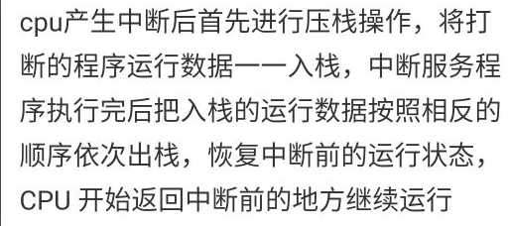
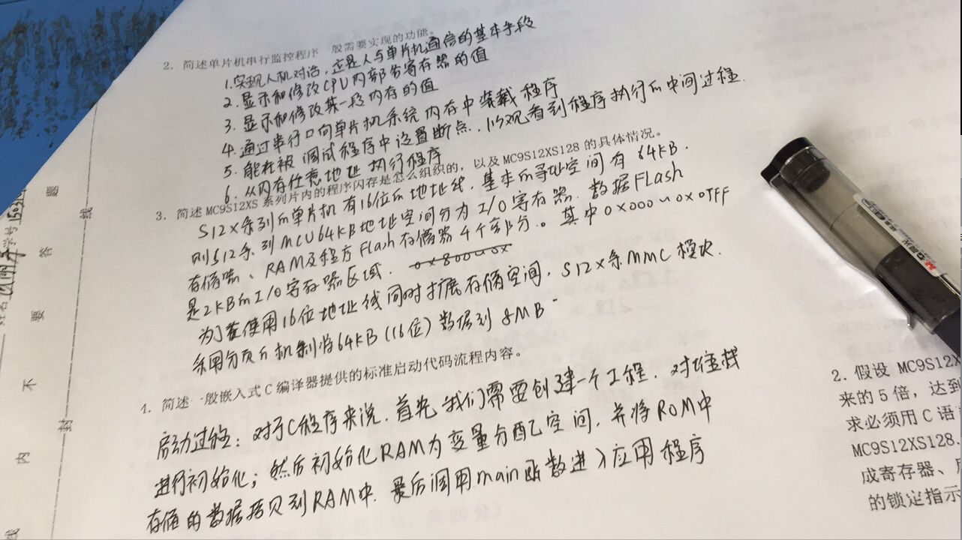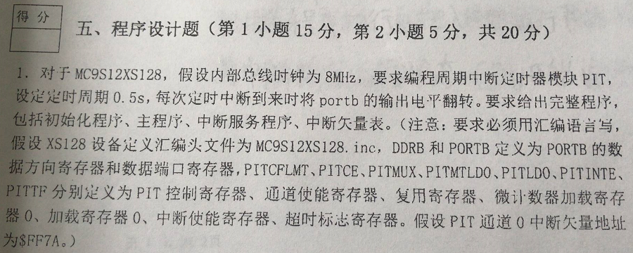
c语言版：
void main(void)
{
/* put your own code here */
SetBusCLK_40M();

DDRB=0XFF; //PB 口设置为输出
PORTB=0XFF; //PB 口初始化输出高电平，即 8 路 LED 全灭

EnableInterrupts; //要打开全局中断，因为 PIT 是以中断的方式来实现的
Pit0_Init();
for(;;) {} //等待中断的到来
/* please make sure that you never leave this function */
}
/*-----------------配置系统时钟------------------*/
void SetBusCLK_40M(void)
{
CLKSEL=0X00; //disengage PLL to system
PLLCTL_PLLON=1; / on PLL
SYNR =0xc0 | 0x04;
REFDV=0xc0 | 0x01;
POSTDIV=0x00; //pllclock=2*osc*(1+SYNR)/(1+REFDV)=80MHz;
_asm(nop); //BUS CLOCK=40M
_asm(nop);
while(!(CRGFLG_LOCK==1)); //when pll is steady ,then use it;
CLKSEL_PLLSEL =1; //engage PLL to system;
}
/*-----------------PIT0初始化------------------*/
void Pit0_Init(void)
{
PITCFLMT_PITE=0; //disable PIT

PITCE_PCE0=1; //enable timer channel 0
PITMUX_PMUX0=0; /0 connected to micro timer 0

PITMTLD0=0XFF ; //micro time base 0 equals 255 clock cycles
PITLD0=0XFFFF; //time-out period = (PITMTLD + 1) * (PITLD + 1) / fBUS.

PITINTE_PINTE0=1; //enable interupt channel 0

PITCFLMT_PITE=1; //enable PIT
}
/*-----------------PIT0中断服务程序------------------*/
#pragma CODE_SEG __NEAR_SEG NON_BANKED
void interrupt 66 PIT0_ISR(void)
{ // 40MHZ 420Ms timer overflow
PITTF_PTF0=1; //CLER FLAG
PORTB=~PORTB;
}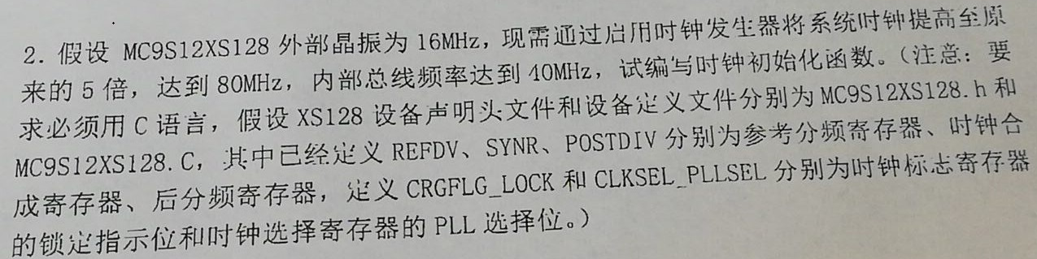
汇编版：
void SetBusCLK_80M(void)
{
CLKSEL=0X00;
PLLCTL_PLLON=1;
SYNR =0xc0 | 0x09;
REFDV=0x80 | 0x01;
POSTDIV=0x00;
_asm(nop);
_asm(nop);
while(!(CRGFLG_LOCK==1));
CLKSEL_PLLSEL =1;
}

